[Chris Meloni on His 'Law & Order' Return, 'Maxxx' and Love for Eccentric Characters (Exclusive)](https://www.etonline.com/chris-meloni-on-his-law-order-return-maxxx-and-love-for-eccentric-characters-exclusive-150161?amp&__twitter_impression=true&s=09)

**Stacy Lambe‍**

1:57 PM PDT, July 23, 2020

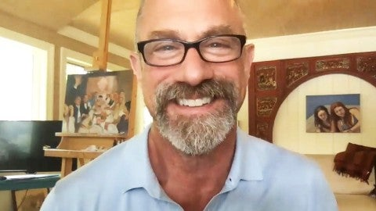

After notable and acclaimed guest roles on shows like [***The Handmaid’s Tale***](https://www.etonline.com/the-handmaids-tale-christopher-meloni-talks-commander-winslow-and-that-juicy-billiards-scene-127463) and *Pose* as well as leading the short-lived Syfy series *Happy*, [**Christopher Meloni**](https://www.etonline.com/people/christopher-meloni) is making a [**welcome return to the world**](https://www.etonline.com/elliot-stabler-is-back-what-chris-melonis-return-means-for-the-law-order-universe-144057) that made him a TV favorite: *Law & Order*.

This fall, the actor is slated to reprise his *Law & Order: Special Victims Unit* role, [**Elliot Stabler**](https://www.etonline.com/christopher-meloni-reprising-svu-character-det-elliot-stabler-for-new-nbc-series-143986), in a new spinoff, titled [***Law & Order: Organized Crime***](https://www.etonline.com/chris-melonis-svu-spinoff-law-order-organized-crime-set-for-fall-2020-debut-148176). The NBC drama will see Elliot returning to the New York Police Department as the city and law enforcement are in the midst of dramatic changes, forcing Stabler to amend his old ways and adapt to a criminal justice system as he leads a new elite task force that is taking on the city’s most powerful criminal syndicates.

When *Organized Crime* premieres, it’ll mark Meloni’s first time playing Stabler in nine years, after his sudden exit from *SVU* in season 12. While fans have long hoped he would return to the series, it wasn’t until now that Meloni says it felt right to step back into Stabler’s shoes.

“A certain piece just fell into place,” Meloni tells ET’s Rachel Smith while promoting his latest role on the British series *Maxxx*. “For me, there were just personal things that I was like, ‘You know, now is a good time.’ That was it. There was nothing secret. It just was effortlessly correct.”

He adds that it’s so rare to have such clarity about a project. “It's one of these [things where] I felt like I believed in the stars and all that… I’d go, ‘Oh, the stars are telling me you know but because it was just right.’”

Meloni is also slated to reunite with his former co-star, [**Mariska Hargitay**](https://www.etonline.com/people/mariska-hargitay), when *SVU*[**returns for its 22nd season**](https://www.etonline.com/christopher-meloni-returning-to-svu-in-season-22-premiere-ahead-of-new-series-145822), marking a long-awaited TV reunion between Stabler and Olivia Benson.

Ahead of filming, which the actor says is slated to start in September, the two [**recently snapped a selfie**](https://www.etonline.com/mariska-hargitay-snaps-selfie-with-christopher-meloni-its-on-149932) together while enjoying time outside the city. Joking in the caption that “it’s on,” the Instagram got fans excited about what’s to come for the two co-stars and their characters.

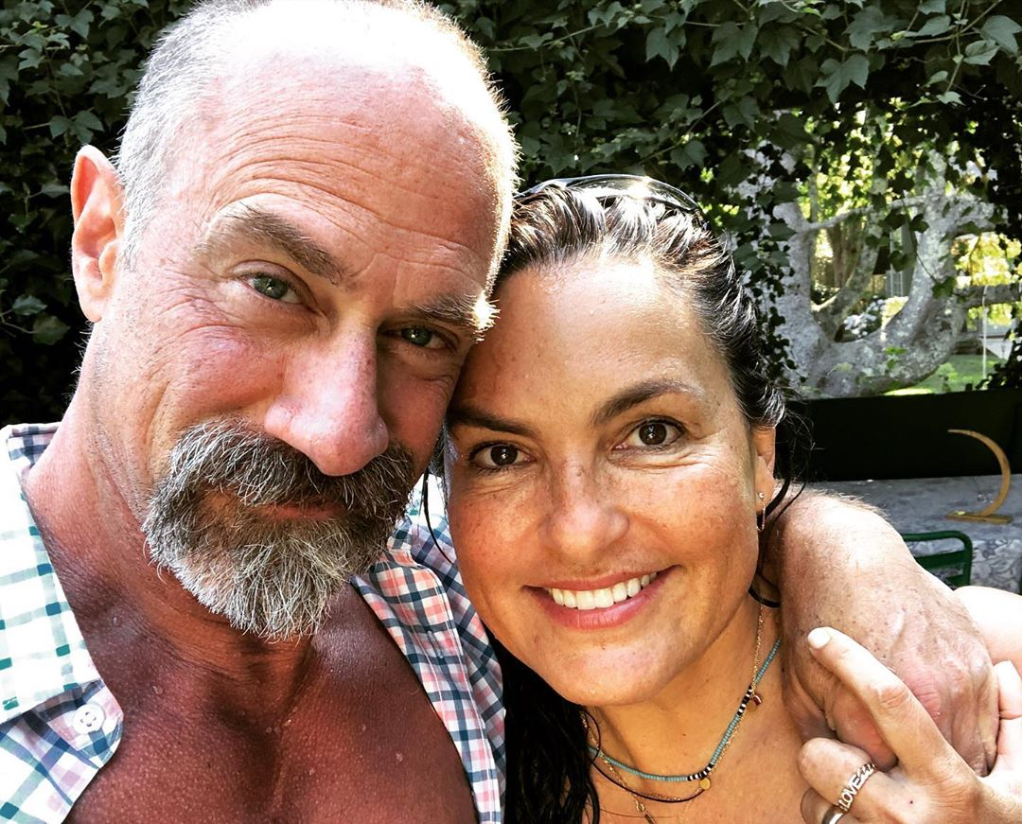

“[*SVU*] gave birth to Mariska and Meloni, and Benson and Stabler. So we’re kind of inextricably linked and connected in that way,” Meloni says of the bond the two will always have. “Beyond that, we’re very good friends. I think we value each other.”

Whenever it comes to getting back together, he says, “We just pick it up right where we left off and we’ve said it’s like we don’t have this relationship with anyone else… It’s unique, it’s full of laughter, she’s full of love. We just kind of fall seamlessly into that place every time we see each other.”

In the meantime, fans of Meloni can watch him on *Maxxx*, which makes its U.S. debut on Hulu. The actor plays eccentric record producer and music manager Don Wild on the series about a washed-up boy band singer Maxxx ([**O-T Fagbenle**](https://www.etonline.com/the-handmaids-tale-o-t-fagbenle-reveals-how-elisabeth-moss-helped-him-film-a-pivotal-scene)), who attempts to make a return to stardom while trying to win back his supermodel ex-girlfriend (Jourdan Dunn).

Don is the latest in a long line of offbeat, edgy scene-stealing characters Meloni’s played onscreen, in everything from HBO’s *Oz* to *Harold & Kumar Go to White Castle* and most recently on *Happy*. “I’m like the bad kid in the back of the classroom. I’m just attracted to like-minded characters, you know, the bad boys in the back of the class,” he says.

“I think of him as a 24-year-old trapped in a 60-year-old body. He’s just this hard-charging, hard-partying, mad genius, nutcase manager-producer,” Meloni says of Don, whom Maxxx convinces to help him with his attempted comeback.

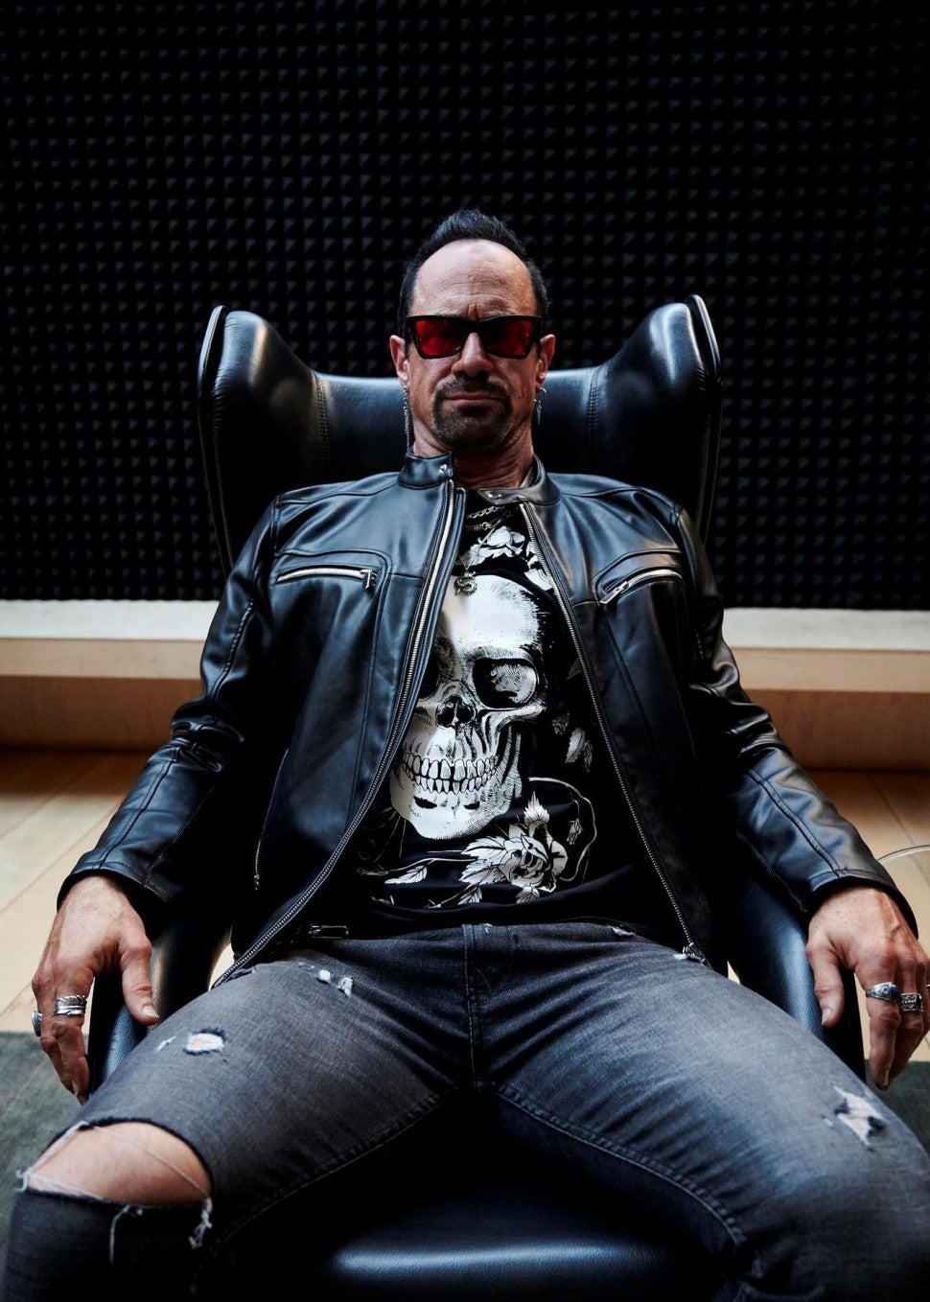

Chris Meloni in Maxxx. Channel 4/Hulu

Making Don even more absurd is the costuming, which includes tinted glasses, ruffled tops and kilts. The first time Meloni got to try on the clothes and looked at himself in the mirror, he knew he had Don all figured out.

“When you’re an actor, there’s such a sense of satisfaction, everything just kind of has to fit right because you’re being another person. And you go, ‘Oh my god, that’s the person. That’s how he would dress. And I know why he dresses this way,’” Meloni explains. “It just makes you feel good, makes you feel safe.”

Ultimately, when it comes to the success of the series, Meloni credits his former *The Handmaid’s Tale* co-star, who also wrote, co-directed and executive produced *Maxxx*. “I didn't know that he was able to wear so many hats,” Meloni says. “He was the guy that you would go to if you had suggestions or changes or whatever. And on top of it, he's almost in every scene. I mean, he really did a magnificent job and he was great.”

*Maxxx* debuts Tuesday, July 28 on Hulu.